**Ideation Phase**

**Brainstorm & Idea Prioritization Template**

| Date | 19 September 2022 |
| --- | --- |
| Team ID | IBM-Project-10558-1659186640 |
| Project Name | Deep Learning Fundus Image Analysis for Early Detection of Diabetic Retinopathy |
| Maximum Marks | 4 Marks |

Reference: <https://app.mural.co/t/kct6313/m/kct6313/1664129042530/f47a3e69632f5d92f72daba7ba284e2a0857559b?sender=ue56305d3f38b1bc35ac56273>

**Step-1: Team Gathering, Collaboration and Select the Problem Statement**

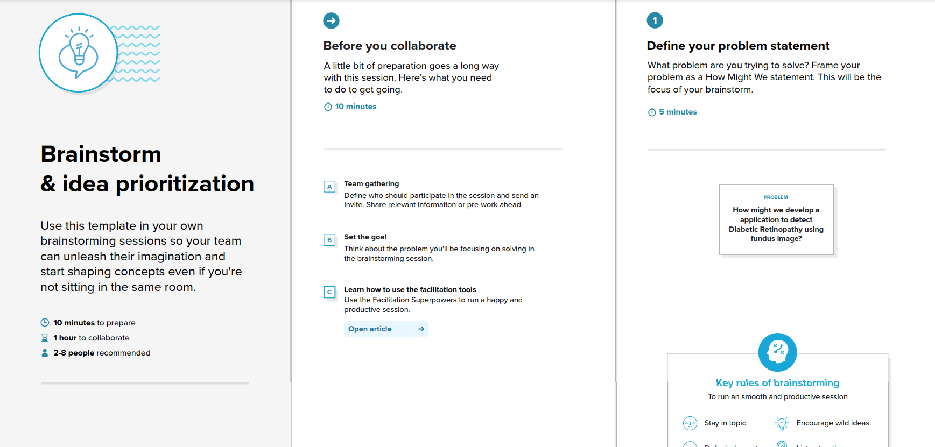

**Step-2: Brainstorm, Idea Listing and Grouping**

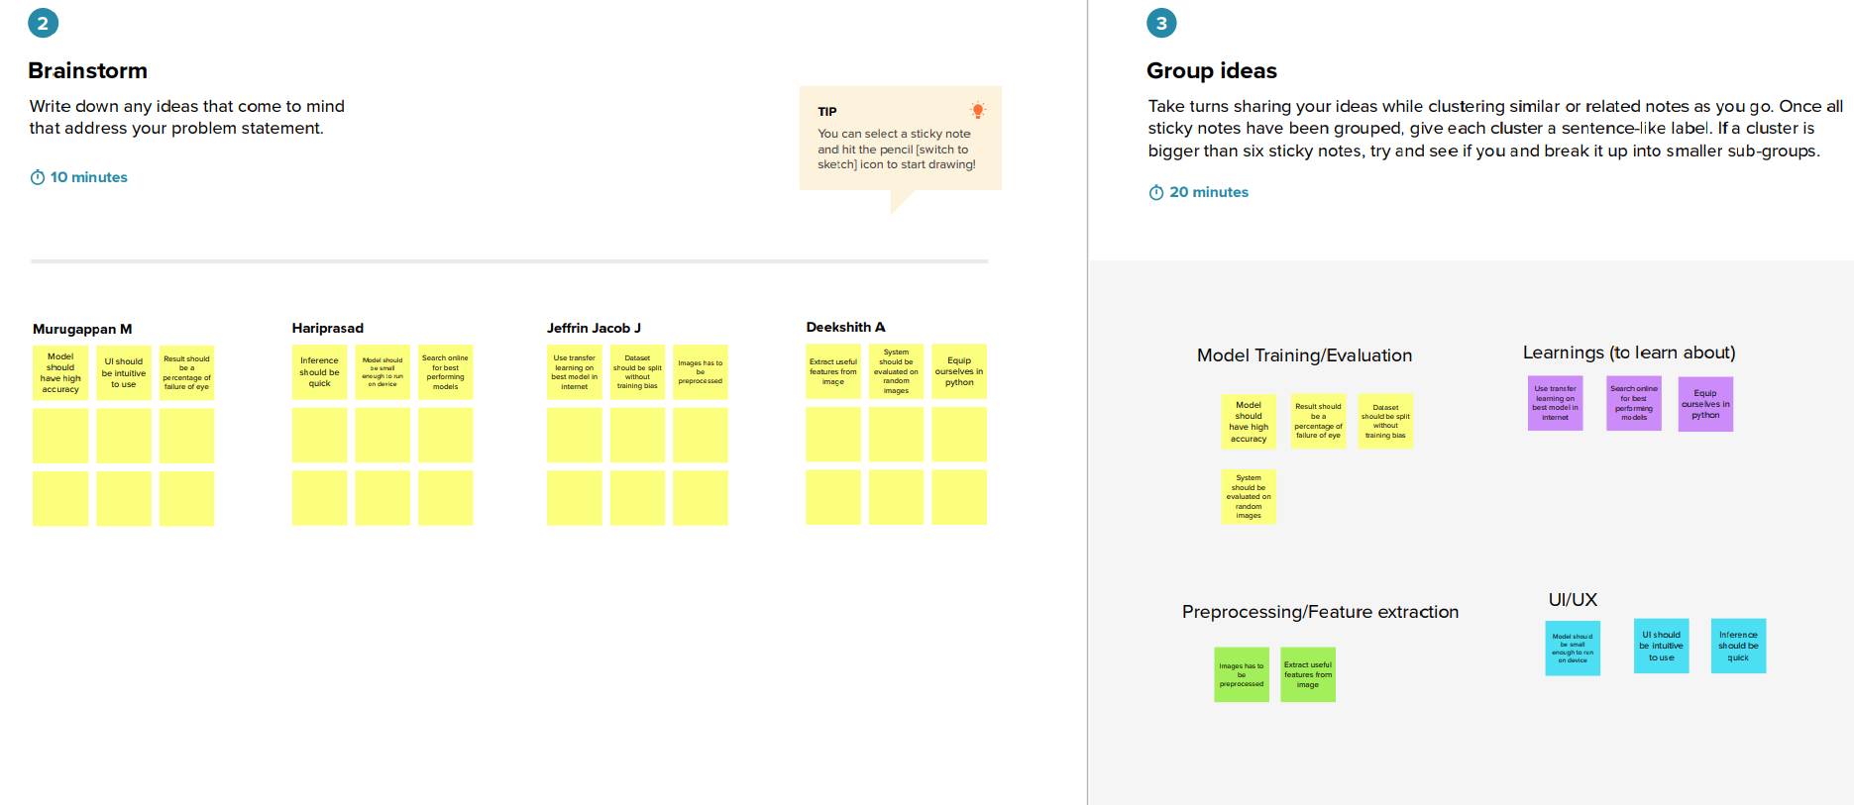

**Step-3: Idea Prioritization**

